**Week 2 Day 1 Tasks**

**Task: Creating and Modifying Variables**

**Objective: Learn how to create and modify variables in Python.**

**Question: What happens if you try to change the value of a string variable to an integer? Does Python allow this type of modification?**

Yes, Python allows this type of modification because it is dynamically typed. We can reassign a string variable to an integer without any issue.

**Task 2: Understanding Data Types**

**Objective:** Understand how to work with Python's basic data types.

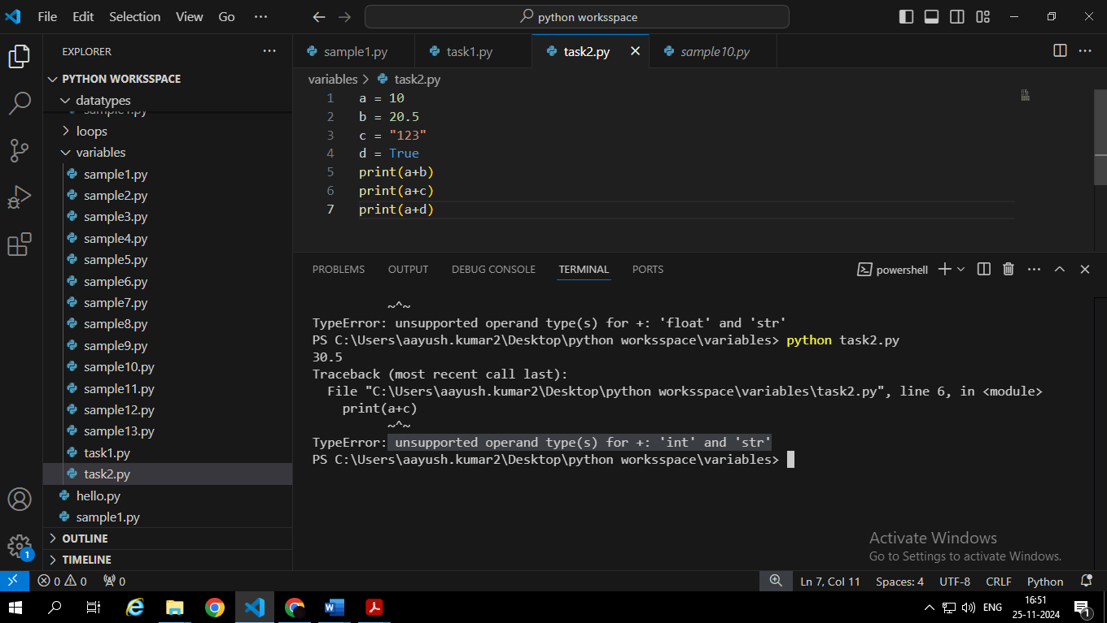

**Question: What is the result when you add a string to an integer? How does Python handle type compatibility in this case?**

It will result a TypeError **“unsupported operand type(s) for +: 'int' and 'str'”,** as Python doesn’t implicitly convert between incompatible datatypes like strings and integers.

We can handle this compatibility issue :

* Convert the integer to a String
* Convert the string to an Integer

**Task 3: Using Conditional Statements (if-else)**

**Objective:** Practice using if-else conditional statements.

**Question:** How would the program behave if you enter a non-numeric input?

If we enter any non-numeric input in the above program then a ValueError appears saying **ValueError: invalid literal for int() with base 10: 'a'.**

**Task 4: Writing a Program with Multiple Conditions**

• **Objective:** Work with multiple conditions using elif.

. Write a program that checks the grade of a student based on their score

**Steps:**

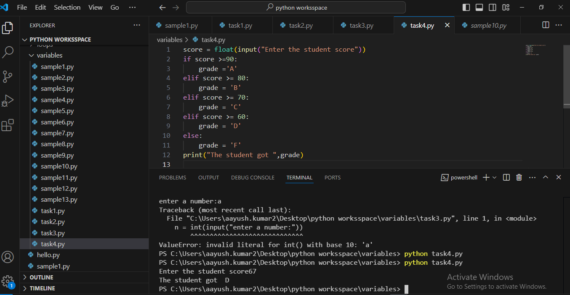

**Question:** How can you modify the program to handle invalid scores (e.g., scores greater than 100)?

We can modify the program by adding a condition that if score >100 then print invalid score.

**Task 5 : Using While Loop**

**Objective:** Learn how to implement a while loop in Python.

**Steps:**

1. Create a while loop that prints numbers from 1 to 10.

1. Modify the program to print only even numbers.

**Question:** What will happen if the condition in the while loop is never updated?

If the condition in a while loop never updates, the loop will continue to execute indefinitely, leading to an infinite loop.

**6. Task: Using For Loop**

**Objective:** Understand the use of a for loop for iterating through a sequence.

**Steps:**

1. Use a for loop to print each item in a list.

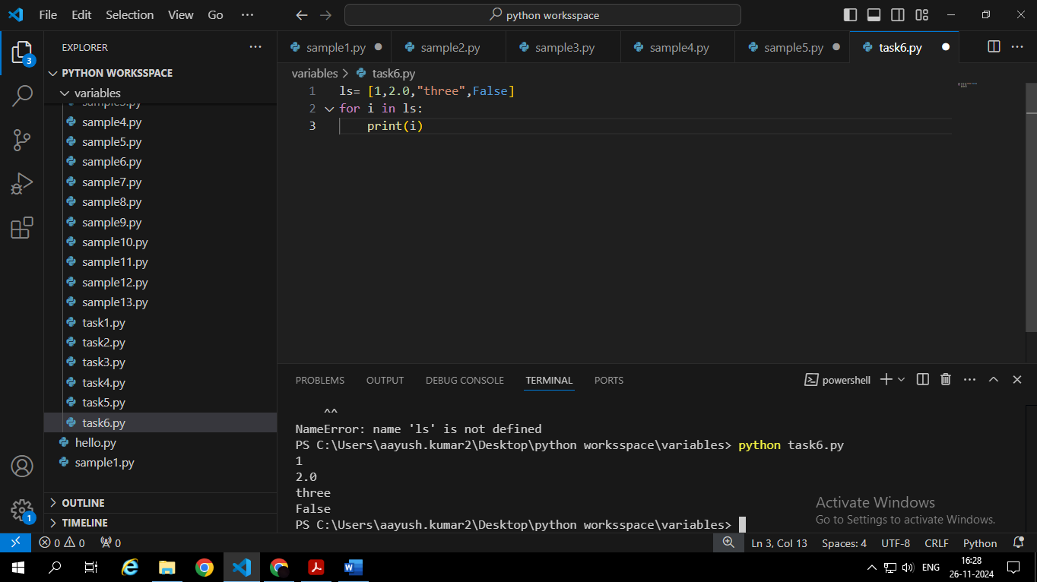

1. Modify the program to print the length of each string in the list.

**Question:** How would you modify the loop to iterate through a dictionary?

* We use the items() method to get key-value pairs from the dictionary.
* The for loop unpacks each pair into key and value variables.
* We then print both the key and the corresponding value.

**7. Task: Break and Continue Statements**

**Objective:** Learn how to control loop execution using break and continue.

**Steps:**

1. Create a loop that iterates over numbers 1 through 10.
2. Use continue to skip odd numbers.
3. Use break to exit the loop when the number reaches 7.

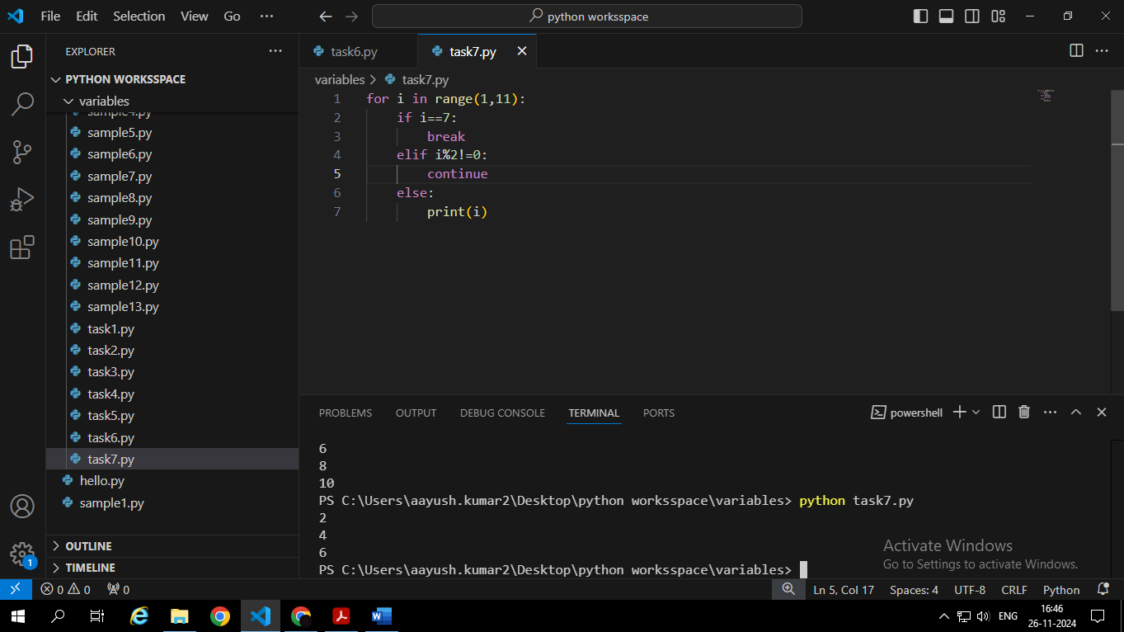

**Question: How does the behaviour of the loop change when break or continue is used?**

• **Continue**: When the continue statement is encountered, the current iteration is immediately terminated, and the loop moves on to the next iteration. In this case, odd numbers are skipped.

**• Break:** When the break statement is executed, the entire loop is terminated, and the program continues with the next statement after the loop. In this case, the loop stops when the number reaches 7.

**Task 8: Type Casting (Implicit and Explicit)**

**Objective: Understand type casting in Python.**

Steps:

1. Create variables of type int and float.
2. Add an integer and a float, and print the result (implicit casting).

1. Explicitly cast a float to an integer and print the result.

**Question: What happens to the decimal part when you cast a float to an integer?**

When you use the int() function to cast a float to an integer, the decimal part is truncated. This means that the number is rounded down to the nearest whole number**.**

**9. Task: Handling Exceptions (Try-Except)**

• **Objective:** Learn how to handle errors using try and except.

• **Steps:**

1. Write a program that asks the user for a number and divides 10 by that number.

1. Use a try-except block to handle the ZeroDivisionError.

• **Question:** What will happen if the user enters a non-numeric value?

**10. Task: Writing a Function with Arguments**

• **Objective:** Learn how to define functions and use parameters.

• **Steps:**

1. Write a function that takes two numbers as arguments and returns their sum.

2. Call the function with different arguments.

• **Question:** How would you modify the function to return the product of the two numbers instead of the sum?

